BRAINWARE UNIVERSITY
ML PROJECT-BASED LEARNING REPORT (WEEK 5)

1. Basic Information
Title of the Project: | Password Strength Checker & Email Validation System (Program 1 & 2)
Name(s) of Student(s): | Soumyadwip Das (BWU/BTS/25/169)  Ankita Paul (BWU/BTS/25/180)  Sonia Naskar (BWU/BTS/25/195)  Joyeta Mondal (BWU/BTS/25/214)  Sayantan Bharati (BWU/BTS/25/503)
Programme & Semester: | B.Tech CSE & 3rd Semester
Course Name & Code: | Python Programming Lab (BES09013)
Name of the Guide/Supervisor: | MR. PRANAB GHARAI & MR. INDRANIL DAS
Project Date | 07/07/2026

2. Introduction and Background
Week 5 focuses on two console-based text-processing utilities: a Text Encryption & Decryption Tool using a character-shift cipher, and a Word Frequency Counter for analysing words and characters. These programs introduce text transformation, ASCII arithmetic, cleaning, and tokenisation.

3. Objectives of the Project (Week 5)
Program 1 - Text Encryption & Decryption Tool
- Create a boxed console-based encryption/decryption tool.
- Implement a reversible printable-ASCII character-shift cipher.
- Use reusable shift(), encrypt(), and decrypt() functions.
- Verify that decrypted text matches the original message.
Program 2 - Word Frequency Counter
- Create a boxed console-based word and character counter.
- Remove punctuation and symbols before word splitting.
- Implement independent word and character counting.
- Test the tool with irregular spacing and punctuation.

4. Problem Statement / Driving Question
Program 1: How can text be transformed using a simple reversible character-shift algorithm while allowing exact recovery of the original message?
Program 2: How can raw text be cleaned and divided into words to produce accurate counts despite punctuation and spacing variations?

5. Methodology (Week 5 Activities)
Program 1 - Text Encryption & Decryption Tool
- Implemented shift() using printable ASCII codes (32–126) and modulo arithmetic.
- Used positive shifts for encryption and negative shifts for decryption.
- Added a continuous menu with error handling.
- Tested encryption and decryption to confirm accurate recovery.
Program 2 - Word Frequency Counter
- Reused the boxed console interface.
- Created clean_text() to replace unwanted symbols with spaces and split text into words.
- Implemented separate functions for word and character counting.
- Added a continuous menu and tested punctuation-heavy and irregularly spaced text.

6. Expected Outcomes / Deliverables (Week 5)
- Functional encryption/decryption and word-counting utilities.
- Clear, consistent boxed terminal interfaces.
- Understanding of ASCII arithmetic and text tokenisation.

7. Core Logic
Program 1 - Character-Shift Cipher
The shift() function is the core of the encryption tool. It converts each character to its ASCII code, adds (or subtracts, for decryption) a fixed offset, and wraps the result using modulo 95 so it stays within the printable ASCII range. Because encrypt() and decrypt() both call the same shift() routine with opposite signs, the cipher is fully symmetric and reversible.
def shift(text, amount):
out = []
for ch in text:
code = ord(ch)
if 32 <= code <= 126: # shift only printable ASCII
code = ((code - 32 + amount) % 95) + 32 # wrap within range
out.append(chr(code))
return ''.join(out)

def encrypt(text):
return shift(text, SHIFT)

def decrypt(encoded):
return shift(encoded, -SHIFT) # reverse shift to recover text

Note: the shift amount is currently a fixed constant (SHIFT = 5) rather than a user-supplied key; making the shift key configurable at runtime is planned as a future enhancement.
Program 2 - Text Cleaning and Word Counting
The clean_text() and counter_words() functions together turn raw input into an accurate word count. clean_text() replaces every punctuation or symbol character with a space, and counter_words() then splits the cleaned text and discards any empty tokens produced by consecutive separators, giving a reliable word count regardless of formatting irregularities in the input.
def clean_text(text):
for char in chars_to_remove:
text = text.replace(char, " ") # strip punctuation/symbols
return text.split(" ")

def counter_words(text):
word_list = [word for word in clean_text(text) if word != '']
return len(word_list), word_list # ignore empty tokens

Note: clean_text() currently strips a fixed, hard-coded list of punctuation characters; extending this to a configurable or locale-aware character set is a possible future enhancement.

8. Output Screenshot
Program 1 - Text Encryption & Decryption Tool
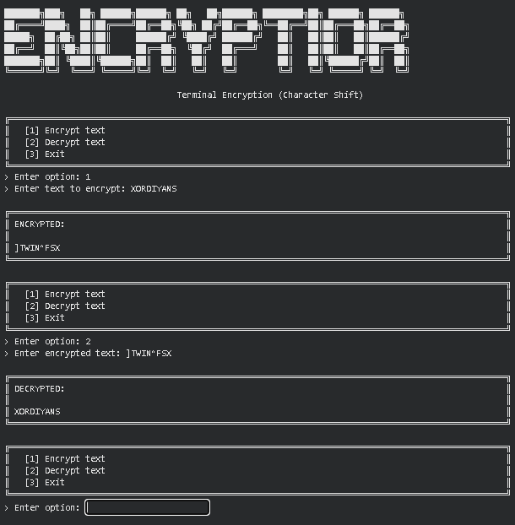
Program 2 - Word Frequency Counter
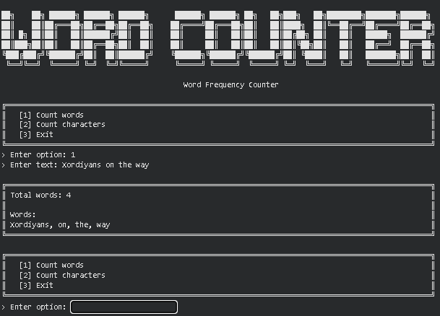

9. Tools & Technologies Used
Tool / Technology | Purpose
Python 3.x | Core programming language used to implement both console utilities
ord() / chr() | Converting characters to and from their ASCII code points for the shift-cipher
Modulo Arithmetic | Wrapping shifted character codes within the printable ASCII range (32-126)
str.replace() / str.split() | Stripping punctuation and splitting text into individual words for counting
List Comprehensions | Filtering out empty tokens when building the word list
Functions & Control Flow | Modularising the encrypt/decrypt routines and the word/character counting routines

10. References
- Python Official Documentation: https://docs.python.org/3/
- Python Built-in Functions (ord, chr): https://docs.python.org/3/library/functions.html
- Python String Methods Reference: https://docs.python.org/3/library/stdtypes.html#string-methods
- Brainware University - Machine Learning Course Guidelines

11. Signatures
Signature of Student(s): Date of Submission:

Signature of Guide/Supervisor:

